Competitor Analysis

“Smart Closet – Fashion Style” = rated 4.1/5 stars on Google Play Store

The Smart Closet has a lot of options which allow to add different clothing and also make outfits, you can even sort the clothes into seasons (Spring, Summer, Fall, Winter or for all seasons). The app also allows you to check statistics, which include total value of your closet, number of clothes, most often worn clothing, etc. There an option to shop and scroll through new clothes, that can bring some inspiration to the user. This app is similar to our idea in some ways, such as having clothes sorted into different categories and seasons. However, this app looks quite blunt and dull, therefore users could get bored of it and switch to a different app. Fortunately, it is very easy to use and has a lot of features in its free version.

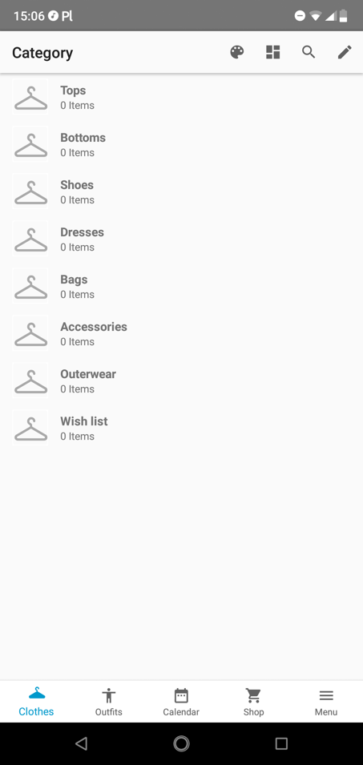 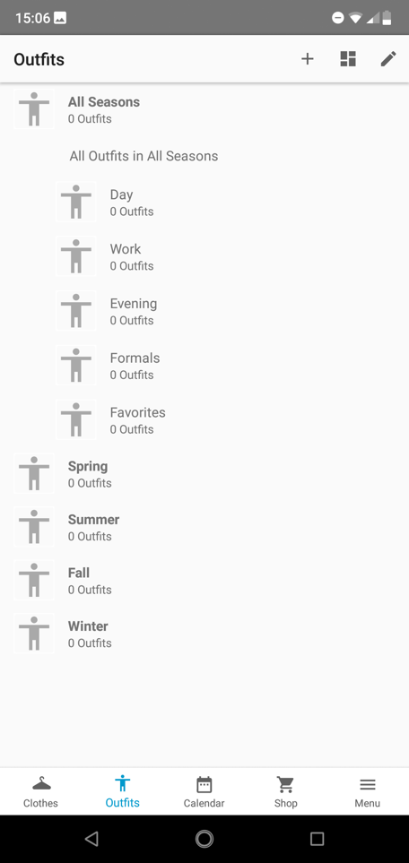 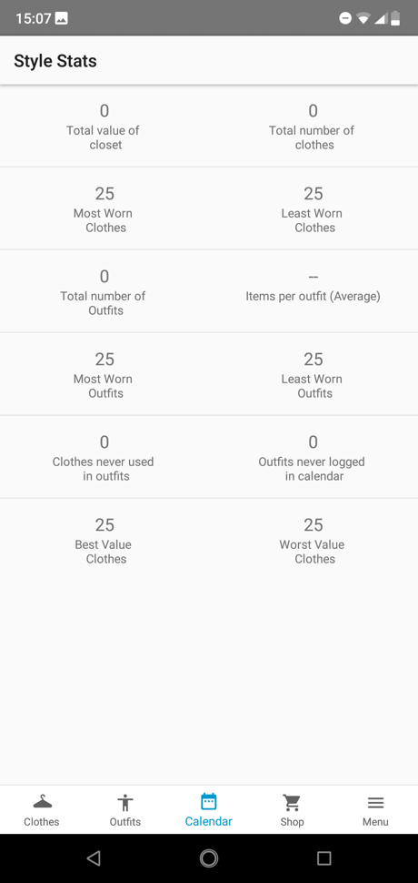

“Your Closet – Smart Fashion” = rated 4/5 stars on Google Play Store

This app has very similar features as the Smart Closet app, unfortunately it doesn’t feature categories for the closet with different seasons and styles. New features that the other app doesn’t have is that it has an option to sort the clothes by colour, you can also sign up, therefore it will be able to save your closet and probably more. Similar to other apps you can check your statistics. Your Closet also has a lookbook page that includes articles from the fashion bloggers, which you can like and fallow. The fashion articles include a lot of images and are presented in style which is good for inspiration for the outfits. Because this app is missing the very useful categorization of the clothes that the previous app had, it gets slightly lower ratings from its users than the other apps. The other causes of this could be that the statistics page doesn’t include enough information.

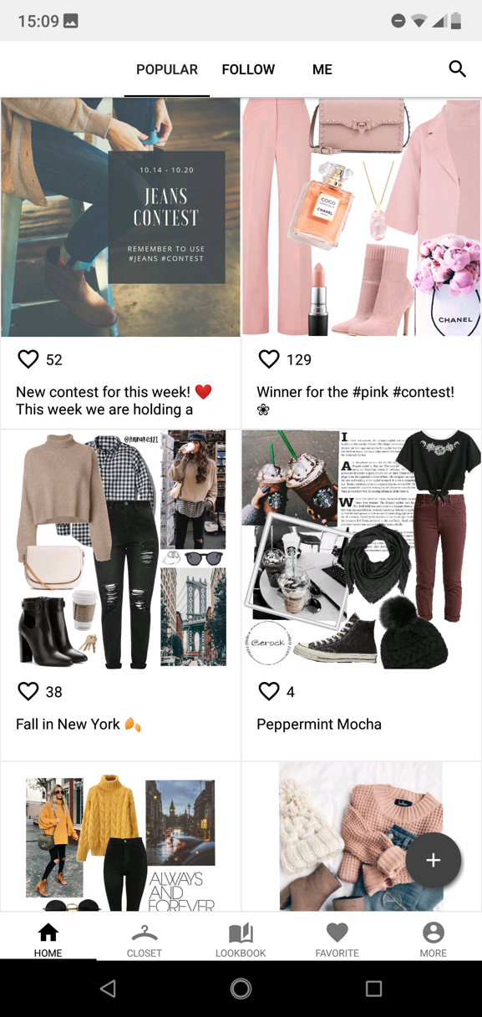 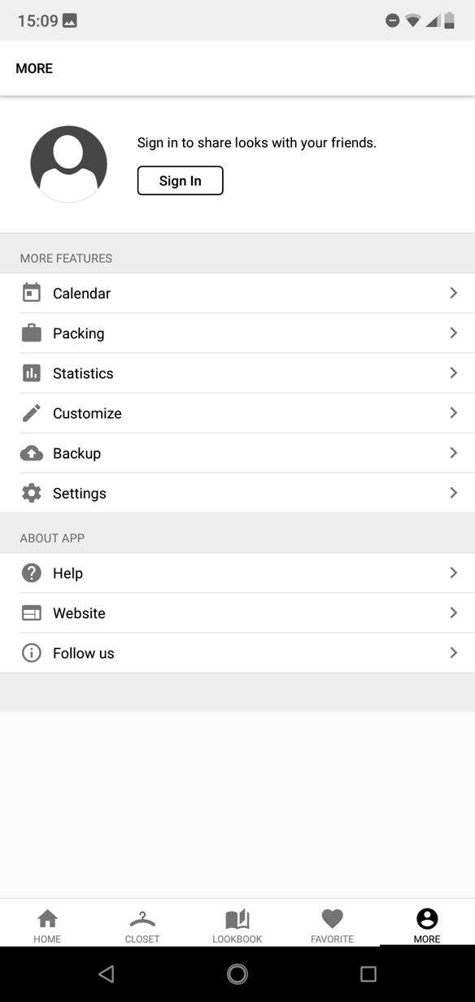

“combyne – your perfect outfit” = rated 4.7/5 stars on Google Play Store

combyne has almost everything that the previous apps have. Except for the seasons categorization, but you can also sort your outfits into occasions. The app requires you to sign up first, which is easy as you can sign up with Google, Twitter, Facebook or email. As you sign up you are welcomed with a guide on how to use this app. Then you are able to create your outfit in a fun style that allows you to add clothes on different parts of the body, when you are done with your outfit you can share or save it. There is also a feed wall where you can see what your favourite fashion bloggers or friends are up to. There is also an option to challenge others with which style is better. There is a Match page which shows you suggestions on what you should wear depending on what you like. With all these features and fun and professional design the app gets a higher rating than others.

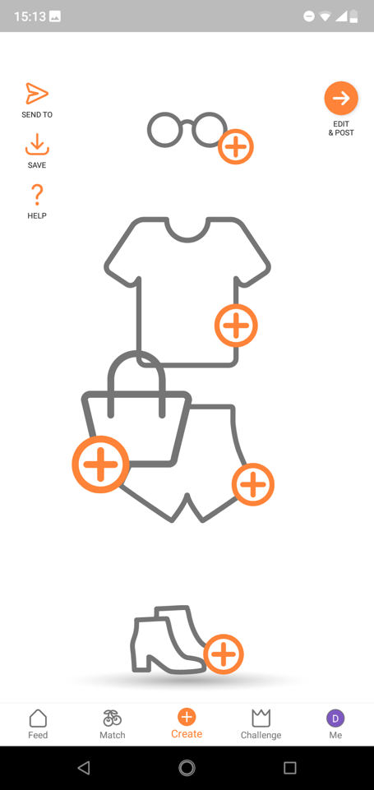 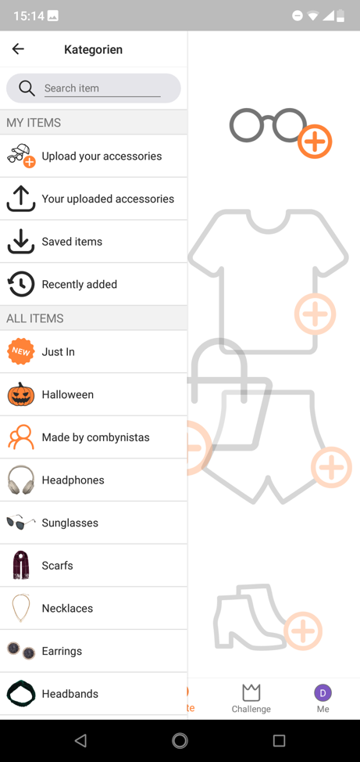 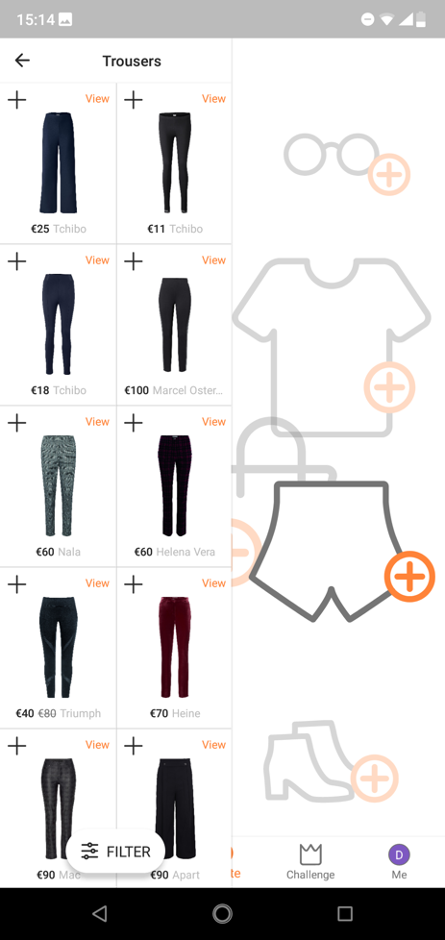

Overall, the competition is hard. Most fashion apps are well designed with user friendly interface. The design of the apps is always stylish and appealing. Most of them seem to go with a light and basic theme. Others like to go with brown/woody theme, that gives a feeling of fall and nature. Our personal favourite is the combine app because it has a very nice and fun design. There is a lot of features that are useful and everything has an icon for easier navigation.

Rabbit Tech Inc, 2018. Smart Closet – Fashion Style (4.0.3) [computer program] Google Commerce Ltd. Available at: <https://play.google.com/store/apps/details?id=com.rkk.closet> [Accessed 11 October 2018].

StyleVault Inc, 2018 Your Closet – Smart Fashion (4.0.10) [computer program] Google Commerce Ltd. Available at: <https://play.google.com/store/apps/details?id=com.yourclosetapp.app.freecloset> [Accessed 11 October 2018].

Combine, 2018. combyne – your perfect outfit (5.4.5) [computer program] Google Commerce Ltd. Available at: <https://play.google.com/store/apps/details?id=com.combyne.app> [Accessed 11 October 2018].